Department of Computer Science and Engineering
Lab Report
Lab Report No | : | 06
Lab Report Name | : | Newton Forward Interpolation & Backward Interpolation.
Course Title | : | Numerical Methods Sessional
Course Code | : | CSE 226
Name | : | Gazi Rishad Kaiser
ID | : | 1120047
Level | : | 6 | Term | : | 2 | Section | : | A | Group | : | 2
Date of Submission | : | -2026 | Semester | : | Spring | Year | : | 2026

Problem: Find the solution using Newton’s Forward Difference Interpolation formula:-
where x=-1
x | 0 | 1 | 2 | 3
f(x) | 1 | 0 | 1 | 10
Key Learnings:
- Learned how to estimate the value of a function at an intermediate point using Newton Forward Interpolation.
- Understood how to construct and use a forward difference table for calculating interpolated values.
Source Code: Input & Output:
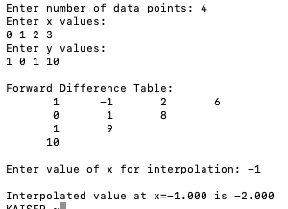
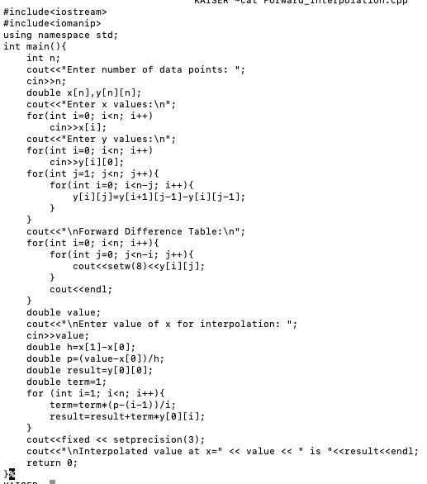

Result Analysis:
The Newton Forward Interpolation method was successfully applied to estimate the value of the function at the desired point. A forward difference table was constructed using the given equally spaced data, and the interpolation formula was used to calculate the unknown value. The obtained result was found to be accurate and consistent with the trend of the given data. The experiment demonstrated that higher-order forward differences improve the approximation and help achieve a more precise estimate. Overall, the results confirmed that Newton Forward Interpolation is an effective and reliable numerical method for estimating function values within the range of known data points.
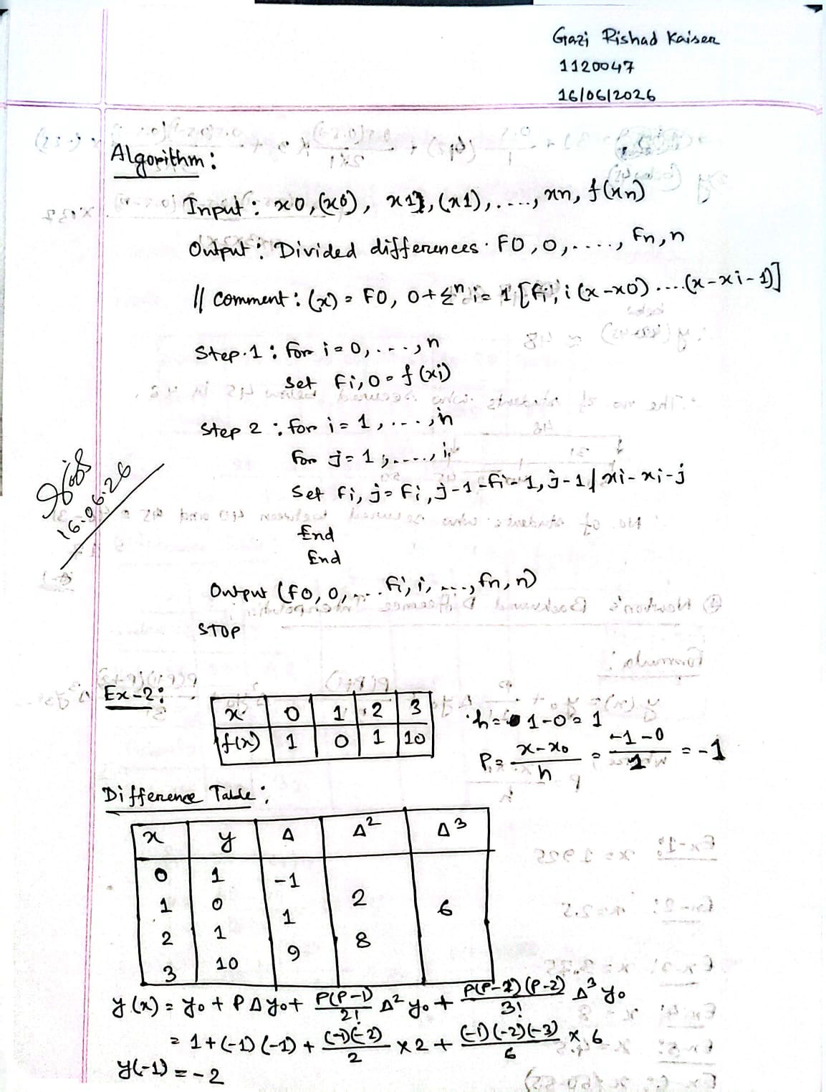

Problem: Find the solution using Newton’s Backward Difference Interpolation formula:-
where x = 8
x | 3 | 5 | 7 | 9
f(x) | 180 | 150 | 120 | 90
Key Learnings:
- Learned how to estimate the value of a function near the end of a data set using Newton Backward Interpolation.
- Understood how to construct and use a backward difference table for interpolation calculations.
- Gained practical experience in implementing the Newton Backward Interpolation algorithm to obtain accurate approximations from equally spaced data.
Source Code: Input & Output:
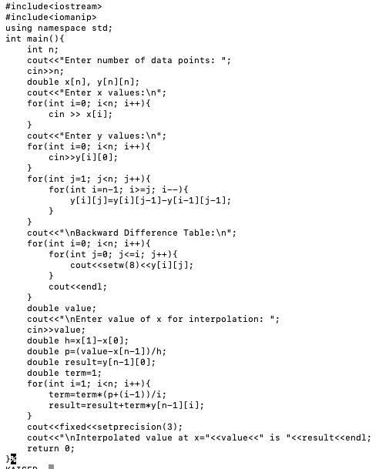
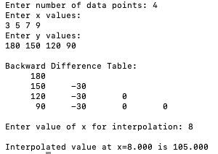

Result Analysis:

The Newton Backward Interpolation method was successfully applied to estimate the value of the function at the desired point. A backward difference table was constructed using the given equally spaced data, and the interpolation formula was applied using the backward differences. The calculated result was found to be accurate and consistent with the pattern of the provided data. The experiment demonstrated that the method is particularly suitable for estimating values near the end of the data set. Overall, the results confirmed that Newton Backward Interpolation is an effective and reliable numerical technique for obtaining approximate values from known data points.

